M26 CSE 250: Circuits and Electronics
Assignment 3
Thevenin, Norton, Maximum Power Transfer Theorem and I-V Characteristics
Question 1.
Obtain the Thevenin or Norton equivalent circuit with respect to terminals a–b and find the maximum power that can be supplied to any load connected to a-b.
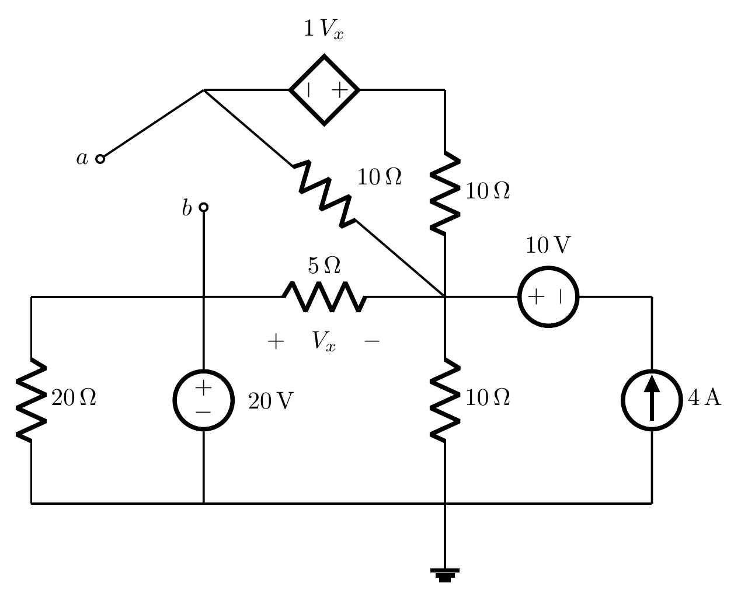
Question 2.
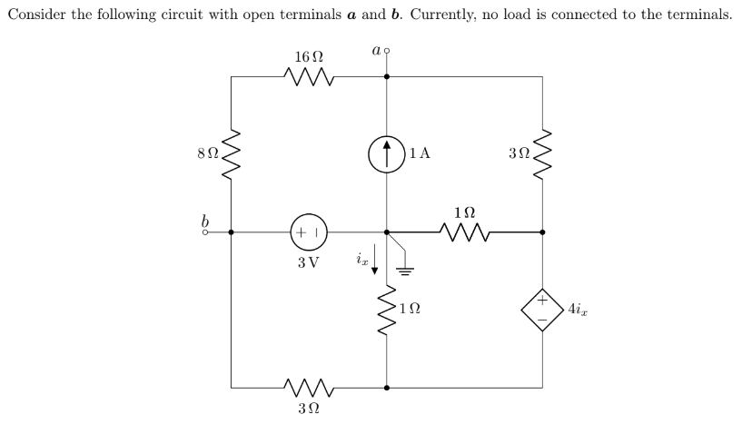
(a) Draw the equivalent circuit using the Thevenin theorem. [3.5 marks]
(b) Find the Norton equivalent current. [1.5 marks]
Question 3.
In the circuit below, all resistors are practical and cannot have negative values. When a voltage of V = 2 V is applied across terminals a and b, the circuit draws a current of I = 3 A. However, if −6 V is applied, instead of drawing, the circuit supplies 1 A to terminal a.
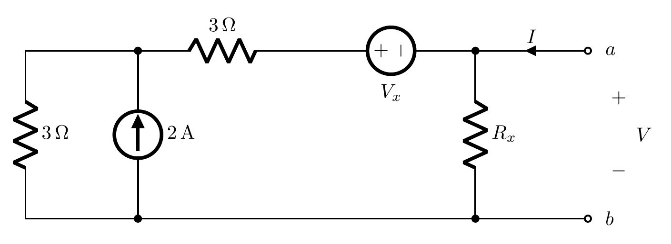
(a) Determine the unknown resistance Rₓ in the circuit. [4 marks]
(b) Find an equivalent representation of the circuit having the minimum number of elements, and determine Vₓ. [6 marks]
Question 4.
Determine the values of Rₜ and vₜ, if the following two circuits are equivalent to each other.
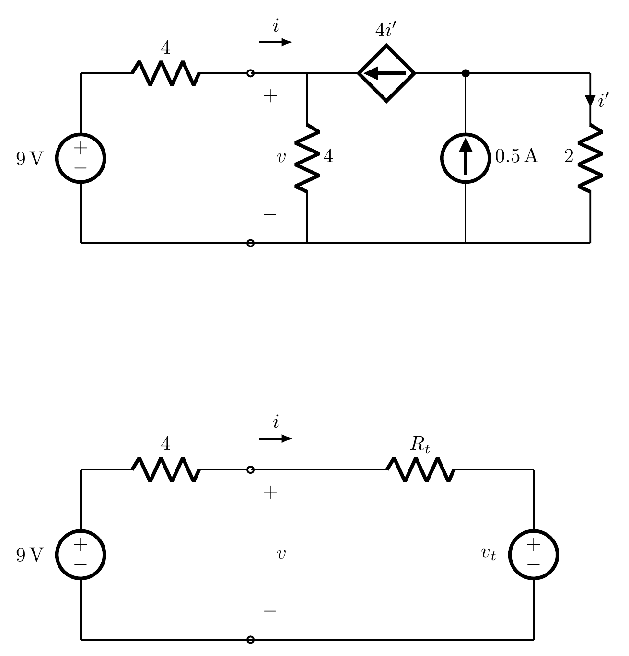
(i) Determine the values of Rₜ and vₜ. [2.5 marks]
(ii) Plot the IV relation of the blue part and find the resistance of the dependent source. [2.5 marks]

